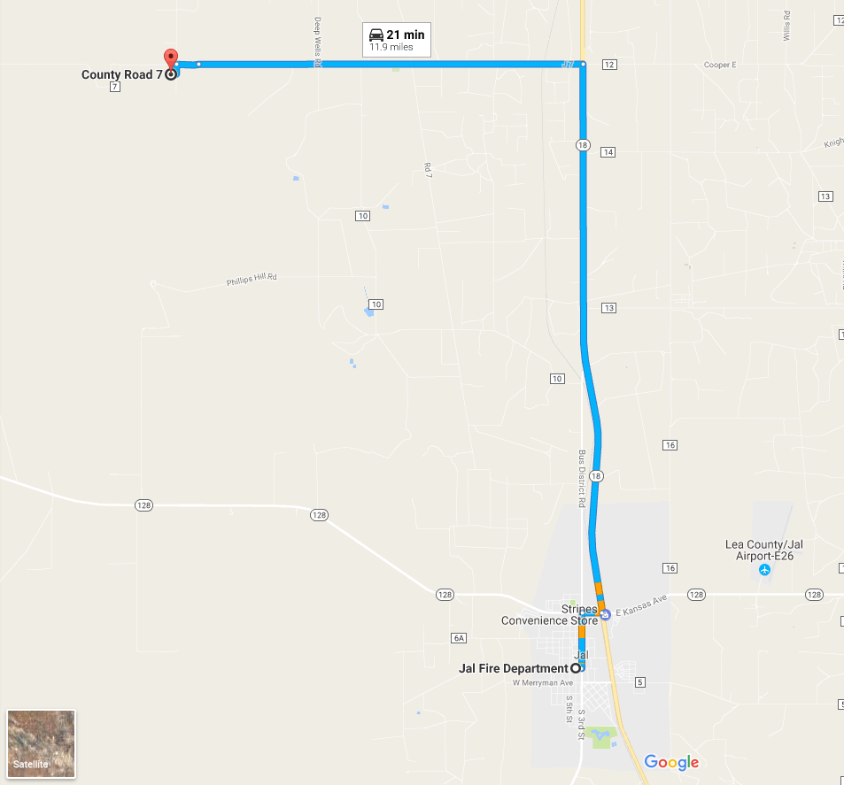

Discovery Education Launch Pad

**Jal Fire Department**

400 S 4th St, Jal, NM 88252

**Take S 3rd St to NM-18 N**

0.9 mi

Head N on S 4th St toward W Panther Ave 10 ft

Turn right at the 1st cross street onto W Panther Ave 374 ft

Turn left onto S 3rd St 0.6 mi

Turn right onto E Kansas Ave 0.2 mi

Turn left onto NM-18 N 6.3 mi

**Turn left onto NM-18 N**

**6.3 mi**

**Follow Cooper Cemetery Rd to Launch Site**

**4.7 mi**

Turn left onto Cooper Cemetery Rd/J 7

Continue to follow Cooper Cemetery Rd 4.4 mi

Continue onto Co Rd 7 0.3 mi

Turn left 0.1 mi

**Discovery Education Launch Pad**

Co Rd 7, Jal, NM 88252

Spectator Check-In starts at 8:00

The first rocket is scheduled to launch at 8:30 from the Discovery Education Launch Pad.

Award Ceremony will begin after rockets have been recovered and all data has been received.